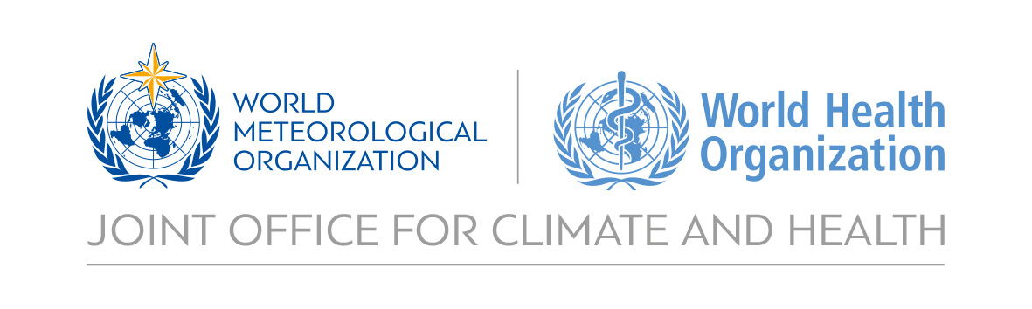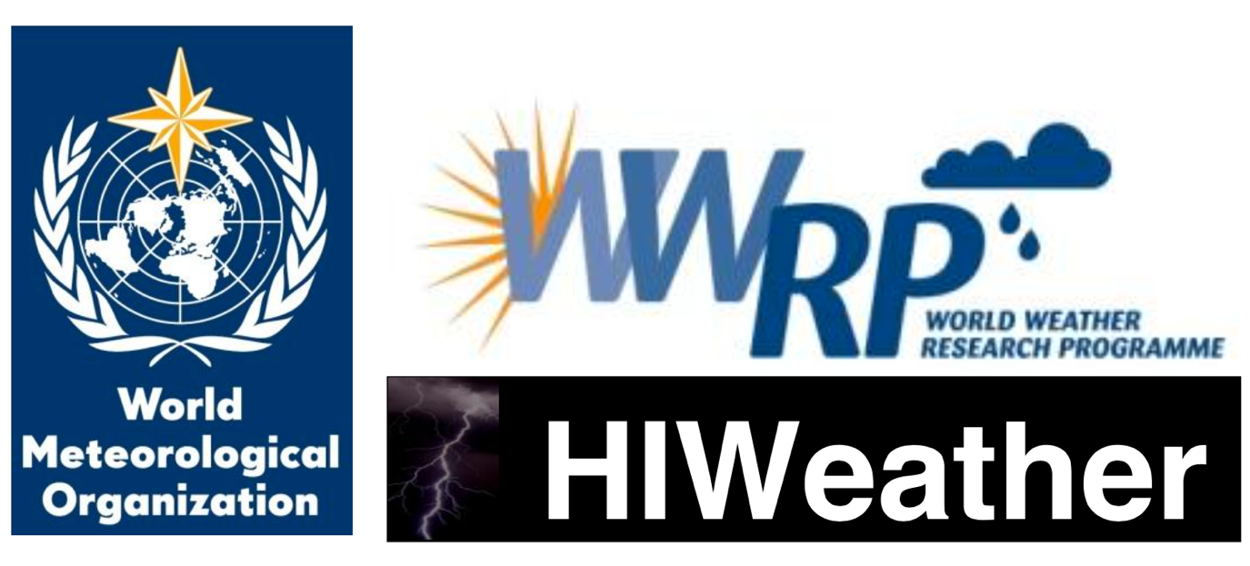

**White Paper on Health Linkages to HIWeather**

**Urban Flood**

**Draft outline**

**Version: 3rd October 2017**

Robbie Parks, Julia Keller, Hannah Nissan, Virginia Murray,

Sarah Jones, Brian Golding,

Paolo Ruti, Joy Shumake-Guillemot

Table of contents

Figures and tables 2

1. Introduction 3

Overview of HIWeather 3

Key goals of HIWeather 3

Health linkages to HIWeather 4

About this white paper 4

Purpose of this white paper 5

Outlines of HIWeather focus areas 7

1. Urban Flood 7

Overview 7

1.1 Health risks 9

1.2 How weather forecasting informs Urban Flood actions plans 11

1.3 Key processes made in preparedness and Flood Action Plans (FAPs) 12

1.4 Key Public Health Needs for improved real-time monitoring, forecasting and alert capabilities 15

1.5 Status of urban flood forecasting and potential for the future with HIWeather 15

1.6 Actionable opportunities for weather forecasts to improve health risk management 17

1.7 Potential pilot projects where improved forecasting could be matched with health risk management needs 19

References 20

Annex 1: Decision-making processes in disaster action plans 22

1. Decision-making structure 22

2. Iterative management of decision-making structure 22

3. Identity of decision makers 24

4. Timeline of key decisions and processes 24

Annex 2: Key metrics to track health impacts of and vulnerability to disasters 26

Annex 3: Flood conditions that would trigger activation of an emergency plan 27

# Figures and tables

Figure 1. Potential flow of information between a lead body and other actors involved in heat action plans. 6

Figure 2. Communications plan for Ahmedabad Heat Action Plan 7

Figure 3. The proposed mechanism for heat health warning system in Thailand. 7

Figure 4. Schematic representation of time frames set out by WHO for implementing the core elements of a heat action plan.3 8

Table 1. Key focal areas of HIWeather and the outline in white paper for each area. 5

Table 2. Indicators from monitoring processes relevant to disasters. 9

Table 3. Flood conditions that would trigger activation of an emergency plan12 11

# Introduction

## Overview of HIWeather

High Impact Weather (HIWeather), a research activity within the World Weather Research Programme (WWRP), aims to improve extreme weather event forecasting, both in spatial resolution and predictive lead time, with the timescales of two minutes to two weeks.

HIWeather is a ten-year succession project (running from 2015-2024) to the THORPEX programme (active from 2005-2014), which delivered major advances in the science of weather forecasting. HIWeather aims to build on the new knowledge science base established by THORPEX activities, as well as new capabilities in short range forecasting from new observations, convective-scale Prediction Models and Ensemble Prediction Systems.

HIWeather’s mission is:

*‘to promote cooperative international research to achieve a dramatic increase in resilience to high impact weather, worldwide, through improving forecasts for timescales of minutes to two weeks and enhancing their communication and utility in social, economic and environmental applications’.*1

Combined with Improved understanding of forecasting systems by social scientists, a dramatic increase in resilience by communities and countries against hazardous weather is possible capitalising on such advances.

## Key goals of HIWeather

HIWeather’s key project goals are to:1

* Improve knowledge and understanding of the processes that generate weather-related hazards so as to assess their predictability.
* Develop multi-scale coupled forecasting systems of the weather-related hazards, including new observation sources, advances in data assimilation and modelling and ensemble prediction, and definition of new products.
* Improve knowledge, understanding and modelling of the exposure and vulnerability of society, businesses, environment and infrastructure to hazards and obtain data and develop tools and models to assess the resulting risk.
* **Improve knowledge and understanding of the processes and variables that influence different stakeholders’ decisions using high impact weather forecasts and warnings, and of the characteristics of information communication that lead to effective responses.**
* Develop improved methods of verifying forecasts, hazard warnings and people’s responses so as to permit evaluation of each stage in the complete production chain.

## Health linkages to HIWeather

Disasters globally since 1990 have caused the deaths of over 1.6 million people.2 A significant beneficiary of HIWeather products could be decision makers in disaster early warning systems and emergency health care provision, who would be able to use improved forecasting techniques to better prepare for approaching extreme weather. The Sendai Framework for Disaster Reduction has the explicitly-stated target of ‘the substantial reduction of disaster risk and losses in lives, livelihoods and health’, which behoves HIWeather to also work towards this goal.3

However, a significant knowledge gap exists in the HIWeather operation plan in terms of **where**, **when**, and **how** significant health care decisions are made, and could be improved using enhances weather forecasting. Further, missing is a detailed awareness of how much lead time is needed for health care decisions. If a significant goal of HIWeather is to improve health outcomes by successful utilisation of its products, the direction of improved HIWeather products must be steered by the awareness and knowledge of the nature of disaster-related health care decisions by the end user in the ‘last-mile’.

This white paper aims to give an exposition on key health risks being managed for each of the 5 HI-Weather focus hazard areas, and the process by which health care decision makers build a timeline of required action.

**The logic of this approach is to begin with the desired health outcome improvements, and work systematically through the processes to identify where HIWeather products could be applied or tailored to assist the health sector.**

In this way, the selection and development of HIWeather products will be informed by how to prevent and reduce health impacts at the heart its direction.

## About this white paper

The seven sections, organized by the HIWeather Focus Areas, describe the associated the health impact to each type of hazard; outline how improved forecasting informs the management of these risks; provide timelines of key decisions; outline the needs in public health for improved monitoring, forecast and alert capabilities; describe current status in forecasting capabilities; key deliverables which could be of value to health professionals, and then identifies potential pilot projects which could be developed for further research and development of these products (Table 1):

Table 1. Key focal areas of HIWeather and the outline in white paper for each area.

|  |  |
| --- | --- |
| HIWeather Focus Areas | Areas of Health Linkages to be outlined for each Focus Area |
| 1. Urban flood 2. Wildfire 3. Localised extreme wind 4. Disruptive winter weather 5. Urban heat waves and air pollution | **1 Health risks.** Summarizes key health impacts associated with each focus weather hazard area, as well as key vulnerabilities.  **2 How weather forecasting informs action plans.** The current ways in which forecasting is beneficial to decision makers.  **3 Timeline of key decisions and processes.** Create timeline of decisions which need to be made by key decision makers.  **4 Key Public Health Needs for improved real-time monitoring, forecasting and alert capabilities.** Identify key gaps in capabilities of forecasting (both in time and space) which can be improved upon to help decision makers make decisions.  **5 Status of current forecasts capability and capacity.** Overview of forecasting capability for the extreme weather, the issues HIWeather would like to tackle for improving capability and coverage.  **6 Actionable opportunities for weather forecasts to improve health risk management.** To improve capabilities of decision-makers to avert disaster-related deaths.  **7 Potential pilot projects where improved forecasting could be matched with health risk management needs.** Potential projects serving as focused health outcome-based research for HIWeather. |

The report annex has an overview of **key decision-making processes and timelines**, as well as **key metrics as trackers for disaster-related health outcomes**.

## Purpose of this white paper

By bringing health and meteorological sectors closer together through sharing of expertise, and an exposition of what is possible and required on both sides for better disaster preparedness, the following three points should be clarified:

1. What is already possible with meteorological and health services working together fully
2. Which outcomes could be possible at the end of HIWeather for health services
3. Where and what are the limitations of HIWeather and weather prediction regarding what health care decision makers would require

With the project goals of HIWeather framed in the context of providing better technical capacity and understanding to health outcomes before, during and after extreme weather, this white paper will provide guidance and a reference to how this may occur.

# Outlines of HIWeather focus areas

## 1. Urban Flood

### Overview

Between 1995 and 2015, 3,062 flood events were recorded4. Floods were responsible for the majority (56%) of natural disasters; affecting 2.3 billion people worldwide4. In the first half of 2017, floods were reported as 44% (66) of 149 disasters worldwide, with 52% (1,644) of the 3,162 deaths during the period5

#### Types of flood

All manifestations of floods can have a significant impact on public health in an urban area.6

While the adverse health effects of flooding include many direct impacts on human health, the pathways can be complicated and indirect. Table 2 lists the types of flood and their cause, with Table 3 listing how they manifest themselves as a disaster.

HIWeather’s forecasting capabilities will be expected to contribute to disaster preparation for flash floods and plain floods (see also 1.6 Actionable opportunities for weather forecasts to improve health risk management).

Table 2 types of flood, by cause

|  |  |
| --- | --- |
| Cause | Examples |
| Heavy of intense rainfall | * slow-onset riverine (fluvial floods) * flash floods * pluvial or surface water flood affecting sewers and urban drainage * groundwater flood |
| Thawing of ice | * glacial meltwater * snowmelt |
| Dam failure | * dam break * dam overtopping |
| Tidal wave or wave extremes | * storm surge * tsunami |

Table 3 manifestations of floods

|  |  |  |
| --- | --- | --- |
| Manifestation | Due to | Occurring in |
| Local, sudden floods (flash floods) | * Flooding in small catchments * Short, intensive precipitation | * Flooding in small catchments * Short, intensive precipitation |
| Extensive, long-lasting floods (plain floods) | * Flooding of larger areas * Rainfall lasting days or weeks * Poor soil saturation * Melting snow and ice | * Plains when dikes or defences along wide rivers can no longer can the flood discharge |
| Coastal flooding | * More inundation of coastal areas than expected from normal tides | * Coastal areas |

#### Definition of a flood

No standard definition of a flood exists for the purposes of hazard risk assessment.7 This is highlighted by the report ‘Floods in the WHO European Region: health effects and their prevention’, where a table of triggers from emergency action plans were compiled from responses by members of the WHO European Region to flood conditions that would trigger activation of an emergency plan (in full in Table 6 in Annex 3: Flood conditions that would trigger activation of an emergency plan).

A selection of examples is shown here in Table 4:

Table 4. Examples of flood conditions that would trigger activation of an emergency plan7

|  |  |  |
| --- | --- | --- |
| **Country** | **Definition** | **Category of definition** |
| Bosnia and Herzegovina | Shortage of safe water and/or houses flooded with water; extensive flooding endangering population settlements, infrastructure, roads, railways, etc. | Population effects |
| Israel | The protocols for mass casualty events are immediately activated in any emergency in which there is a discrepancy between needs and the ordinary resources that are available. When there is a forecast of a potential emergency, such as a flood, the resources are reinforced and alerted in advance. | Temporal perspective |
| Netherlands | If a flood or the threat of a flood occurs on a national level because of a storm surge or high river water levels in one of our two main rivers (Maas, Rijn) | Scientific threshold |

### 

### 1.1 Health risks

#### Immediate onset health concerns of urban floods requiring prevention and emergency management

* **Disruption to essential health care.**

In addition to facilities needing specialized emergency management protocols and services related to the flood event – it is critical for routine health care provision to continue even during times of emergency with little interruption, making available uninterrupted obstetric care services, NCD treatment, mental health management, pharmaceutical and surgical services, etc. This often involves networked patient management across a health care system – referring and transferring patients to appropriate care services.

Treatment for serious illnesses, such as cancer, can be disrupted by flooding, due to transport infrastructure being knocked out for prolonged periods of time.8 Lack of availability of routine prescription medicines due to flooding may also impact health.9 Health care practitioners may also become overwhelmed by the increased demand for services.6

Power generation facilities, such as in Fukushima during the Japanese tsunami event of 2011, can also be taken suddenly offline, with large environmental and power supply deficits. 10

* **Poisoning from chemical contamination.**

Generators used for pumping water overflow and dehumidifying can leak carbon monoxide.11 Chemical pollution of flood-water by, for example, pesticides from farm run-offs, can also present serious risks.12

* **Drowning or physical trauma.**

Rapid rise floods can cause sudden changes to the environment, increasing the risk of drowning and injuries, especially if a flood overwhelms a place of residence.13 Slow rise floods can also be deadly when there is a lack of preparedness.6 Injuries may include snake or other bites.

* **Electrocution.**

For urban authorities, which do not plan for the electricity grid to be shut off before a flood, there can be catastrophic consequences. In the 2011 flood in Thailand, 128 of 919 deaths resulted from electrocution, with a relative risk of 4.1 of electrocution comparing those in urban areas to those outside.14 96% of deaths from electrocution resulted from circuit breakers in houses not being shut off.14

* **Facilitating water-borne and rodent-borne disease transmission.**

Diseases can be spread from contaminated surface water by the onset of flooding.15 Flooding of sanitation facilities, disruption to safe drinking water sources, poor hygiene, contact with contaminated surface waters, displacement and contact with other vectors such as rodents. Increased instances of cholera16, diarrheal diseases16, hepatitis A and E16, leptospirosis16, melioidosis17, respiratory infections18, and typhoid16 have been observed after floods in urban areas.

* **Landslides**

Heavy rainfall can cause large-scale soil displacement, which causes casualties and death, as well as causing economic loss of buildings, livelihoods and business, such as in Colombia and Peru in April 2017.19

* **Protection of high-risk and in-care populations**

Those already suffering from chronic diseases that require around-the-clock attention, such as mental illnesses, or those who require regular treatment for management of diseases, such as dialysis, can be at serious risk if flooding disrupts their access to care.

* **Radiation poisoning from toxic material displacement**

Heavy rainfall causing floods can potentially dislodge previously buried toxic waste and contaminate rivers and water supplies, such as in the aftermath of Hurricane Harvey in Texas, USA in September 2017.20

#### Delayed Health Impacts triggered by flood events

* **Fungus and Mould.**

When flood waters recede dangerous levels of mould grow, particularly in tropical climates and lead to increased asthma, and respiratory complications. Mould can render housing unsafe and uninhabitable within a matter of days.21

* **Vector-borne Diseases: Malaria, Dengue.**

Epidemics in the wake of flooding in tropical regions can occur due to clogging of storm water drains, causing stagnant water to allow genesis of vectors of certain diseases.18,22

* **Malnutrition.**

Damage to infrastructure caused by flood, and disruption to food systems can cause appropriate food to be unavailable for prolonged periods, due to spoilage, in availability, loss of economic of physical access to safe and nutritious food, with the poor, children and the elderly being particularly vulnerable.23

* **Population displacement.**

Mid- to long-term population displacement can put a large strain on resources in areas which neighbour the flooded area. A good example of this is from the floods in Bangladesh in the 1988 flood, where more than 40 million people were displaced and 7.2 million houses were destroyed or damaged.24

* **Psychological distress.**

The mental health effects of a flood can last long after the flood itself, with reports of increased prevalence of psychological morbidity (including depression, anxiety, PTSD) in residents up to 1 year after floods, particularly if residents are displaced at short notice.25,26 Often, the longer-term mental effects of flooding are not considered in FAPs, with the focus instead being on short-term emergency measures.

#### Some risk factors associated with urban flooding

While health impacts of urban flooding could affect anyone in an afflicted population, the following demographics are highlighted as possessing a higher risk of mortality or morbidity during a disaster:27 According to the Public Health England, 6 inches (15.2cm) of fast-flowing water can knock over an adult, while 2 feet will float a car.

A list of those with heightened risk factors include children, pregnant women, the elderly, people with physical, sensory and cognitive impairments, people with chronic illnesses, those receiving care at home (e.g. home oxygen, dialysis), people who are homeless, people with language and cultural-based vulnerabilities, tourists, vehicle drivers.7

PLACEHOLDER FOR VA TABLE

### 1.2 How weather forecasting informs Urban Flood actions plans

#### Role of forecasting technology in FAPs

In the event of an urban flood, monitoring and forecasting are essential and invaluable components of saving lives and livelihoods. However, technology alone is not enough, as ‘introducing new hardware with an insufficient *software* component to help the community assess its value themselves, can lead to surprising, counterproductive and even disastrous results’28

An unfortunate example of such competent technology failing to translate into saving lives is when Cyclone Nargis hit Myanmar in May 2008. Although the Indian Meteorological Department identified the cyclone four days before landfall, the ‘last-mile’ of communication to isolated local communities in the low-lying coastal regions via traditional media (including TV, newspapers and radio) was ineffective. It was also found that there were either inadequate or non-existent evacuation plans in these areas, which compounded to making Cyclone Nargis the worst natural disaster in Myanmar’s recorded history.

As such, it is important that meteorological technologists understand that such hardware fits into a larger plan. A Flood Action Plan (FAP) is a comprehensive, clear, and effective plan involving stakeholders and decision makers from several different sectors, including health and meteorology. A FAP’s goal is to save as many lives and livelihoods as possible given the onset of a flood event.

#### Nature of interventions possible to mitigate effects of flooding

Taking example from ‘The National Flood Emergency Framework for England’, three kinds of intervention to prevent the health effects of flooding:27

* **Primary Prevention.**

These measures are planned far in advance and can be structural (e.g. engineering) or non-structural (policy and organisation). E.g. emergency plans, land use management, tree planting, control of water sources and flow, flood defences and barriers, design and architectural strategies and flood insurance.

* **Secondary Prevention.**

These measures can be taken either just before or during a flood to mitigate the health effects of the flood. E.g. identification of vulnerable or high-risk populations before floods occur (accounting for difficulties in communication and mobility and the needs of people with chronic diseases), early warning systems, evacuation plans including communication and information strategies, and planned refuge areas.

* **Tertiary Prevention.**

These measures can be taken during and after a flood to minimise health impacts. E.g. moving belongings to safe areas, ensuring the provision of clean drinking water, surveillance and monitoring of health impacts, treating ill people, and recovery and rehabilitation of flooded houses.

HIWeather’s primary contribution for improved health outcomes will take place in the secondary and tertiary preventionareas.

#### Advantages for decision makers with accurate and precise forecasting of urban floods

As soon as a trustworthy alert is issued by a meteorological authority of heavy rainfall, cyclone activity or other meteorological events that can lead to flooding, decision makers have limited time to prepare. A good exercise is to understand what can be done with a set period of advanced notice of an urban flood. The following section details health strategies for floods during timescales which are relevant to HIWeather’s goals.

### 1.3 Key processes made in preparedness and Flood Action Plans (FAPs)

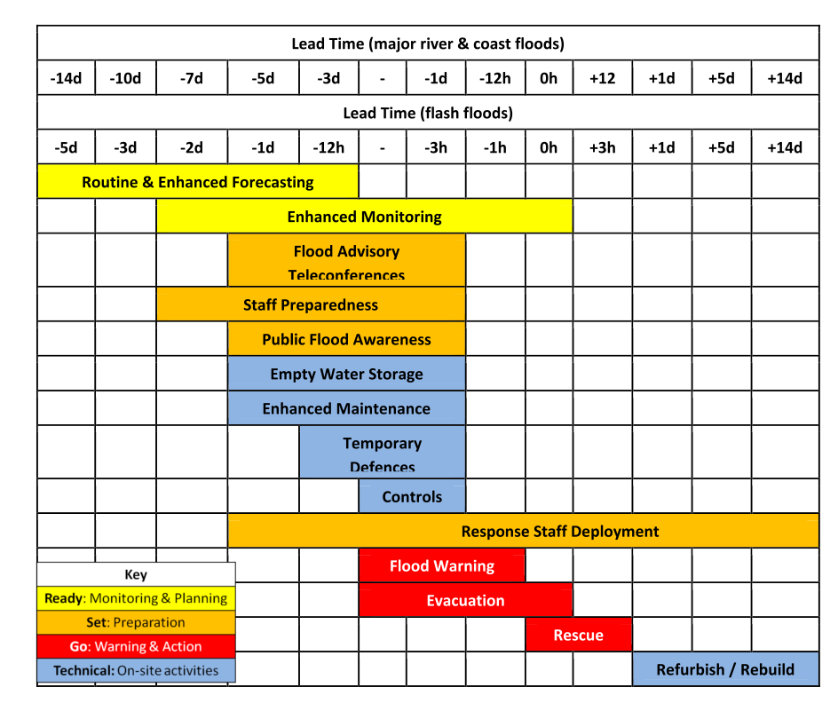

##### Weather prediction (in core interest of HIWeather and WWRP)

Secondary prevention (2 minutes to 2 weeks) i.e. nowcasting, short-term forecasting:

* **Evacuation of low lying communities and health facilities.**

3 days or even longer may be required for an effective evacuation of a densely-populated urban area. [ref]

* **Providing alternative water sources.**

Isolated flood communities will need to ensure they have drinking supplies for this requisite time. 15 litres per person, per day is a recommended amount, while 7 litres per person is classed as a minimum.29 This can be alleviated by independent emergency water tanks and bladders, or supplying mobile purification units connected to the nearest untreated source29 Health facilities require sufficient clean water to maintain health services throughout an emergency.

* **Ensuring continuity of health and social care during a flood.**

Health facilities, social care institutions, and vulnerable communities may be isolated for days. As such, detailed planning must be calculated with weeks of advanced notice

* **Provision of emergency food supplies.**

Minimum three days-worth of food to build up necessary for flash floods. More may be necessary for plain floods with isolated communities.30

* **SOPs for emergency medical transport services during floods.**

Ambulatory care may be required before a flood event to support evacuation efforts, including evacuation of hospitals or care facilities, as well as throughout a flood event. Up-to-date information is required by the ambulatory services of safe transport routes that can be used for road vehicles, or where boats or airlifting will be required.

* **Emergency shelter preparation for displaced communities.**

Communities displaced may have to reside in temporary shelters. These communities need to be pre-identified by authorities and validated to remain safe and functional during the expected magnitude and duration of a flood event. Like food and medical supplies, this may require days of advance preparation and knowledge of safe locations from flood.

* **Vector, rodent, carcass, and waste management**

Plans will need to be made for how to manage sources of disease during flood events – which can result from displacement of rodents into residential and medical facilities; the collection and removal of dead animals; and vector control measures to be immediately activated post-flood to control and reduce breeding sites.

* **Intoxications and chemical poisonings**

Urban flooding heightens risks related to spillage of fuels and industrial chemicals into flood waters that populations can be exposed to. Identifying facilities and transport systems where hazardous materials are located, and monitoring their integrity to contain these toxins is necessary before, during, and after events. Site inspections following a flood event should certify damages and risks.

Secondary prevention (months) i.e. S2S forecasting:

* **Planned emergency management protocols**

WORDS

* **Drilling staff and citizens for urban flood scenarios.**

Finding and training reliable staff for a flood scenario requires significant resources. In addition, holding discussions with vulnerable communities about action plans for floods is important to maximise the effectiveness of contingencies.29

##### Climate prediction (outside core interest of HIWeather but of interest to WCRP)

Primary prevention (years) i.e. long-term forecasts and projections:

* **Adaptation of buildings and urban infrastructure in vulnerable flood plains.**

A long-term preparedness action requires a detailed knowledge of potential flood plains and river overflows. Long-term adaptive action is important in both industrialised and developing nations to safeguard health of vulnerable communities.

* **Flood barriers.**

Building and planning using high-resolution modelling must be enacted long before a flood. Appropriate flood barriers require building to defend against a flood with a return period chosen after flood modelling.31

* **Protection of drinking water sources.**

Long-term decisions in urban areas include slow sand filters, which are also appropriate for large cities like London or Amsterdam, and routing permanent water supplies to avoid potential contamination.29 In developing countries, wells may still be the primary source of water, even in urban areas. Raising the head wall of a dug well, and providing a cover and outward-sloping concrete apron around it is one such way of providing additional security to the supply.29

* **Risk mapping.**

As well as understanding the location of vulnerable houses and buildings (for example in flood plains), this can include ‘the identification and involvement of vulnerable groups and targeted interventions’.7

#### Examples of urban flood current forecasting

* **European Flood Alert System.**

The European Flood Alert System was set up by the European Union in response to the flooding of the Elbe and Danube rivers in August 2002. The system allows national water companies to prepare for flooding by giving medium-range (3–10 days) operational forecasts.

* **Finland.**

The Finnish Environmental Institute has a hydrological forecasting system, the “watershed simulation and forecasting simulation”, which covers the country. The system is based on “ensemble” forecasting techniques and is linked to an automatic flood warning system, which covers 9 days into the future and is updated regularly.

### 1.4 Key Public Health Needs for improved real-time monitoring, forecasting and alert capabilities

* Added lead-time in forecasts better spatial temporal precision
* Clearer articulation of probability and uncertainty
* Visualizations and mapping of spatial and temporal hazard extent
* Wider set of variables and information (see below…)
* Targeted dissemination to pre-identified decision makers/users

### 1.5 Status of urban flood forecasting and potential for the future with HIWeather

#### Background of forecasting progress

Steady increase of scientific knowledge and technological advances since the first ideas of numerical weather prediction in the 1940s have led to a tremendous increase in weather prediction capabilities. Given that global weather prediction is comparable to the simulation of the human brain, this increase in forecast skill, in particular over the last 40 years, is a story of success.32 With every decade, forecast skill is improved by about one day, i.e. today´s overall 6 day forecast is as accurate as a 5 day forecast was 10 years ago.32

Although the increase in these large-scale variables also comes along with increased prediction for weather variables near the surface, and in particular high-impact weather events, one has to keep in mind that clear distinctions exist between what we can forecast on global scales and longer lead times (up to two weeks), and on small scales with lead times of hours to a few days. Current global Numerical Weather Prediction (NWP) model, i.e. models which use physical models and laws using measurements to give boundary conditions to forecast, are able to explicitly capture the large-scale dynamics. Smaller scale processes, in particular those associated with moisture, like clouds and convection, but also radiation and diffusion, and processes at the interface between atmosphere and surface cannot be resolved and captured by current global NWP models. This means that these processes have to be parametrized, i.e. an estimation of the processes is made on the effect they may have and added throughout the model integration. Therefore, the formulation of this estimation is often limited by our understanding of the processes, and some uncertainty is introduced, which then grows from smaller to larger scales, deteriorating also the skill of the global forecasts. On the other hand, this parametrization of clouds, for example, also leads to large uncertainties in the prediction of precipitation.

Regional models can be downscaled from global NWP models to achieve a better spatial resolution, using the boundary conditions of the global models at the edge of the nested high resolution area of interest. Regional models can bring down the resolution to around 2-3km operationally today. [ref]

Many National Meteorological and Hydrological Services (NMHS) run their own regional models. This can bring benefits, but the uncertainties inherent to global models due to parameterization of physical processes can ‘bleed in’ to the regional forecasting, restricting current reliable forecasting to 3-5 days. This can put a severe restriction on how well the forecasting performs against reality (or ‘skill’) of the forecast. The chaotic regime that is a weather system means that small perturbations from reality of initial conditions can result in wildly erroneous forecasts, and hence low forecasting skill.

Forecasting skill can be further eroded by a lack of measurements of climate in the area of interest. For this reason, forecast skill between the Northern Hemisphere (where there has usually been a very good measurement coverage), and the Southern Hemisphere (where there has been a dearth of measurement capability) has historically been different by up to 10%.32

#### Forecasting urban floods

Given how forecasts is produced, urban flooding forecasting capabilities vary depending on the regional system and the measurement infrastructure. Another important factor is how the floods take place. As the ‘Types of flood’ section describes above, urban floods can result from **heavy or intense rainfall**, **thawing of ice**, **dam failure** or **tidal wave extremes**.

For events that result from larger-scale weather systems, like extratropical cyclones, information about the impact might be available on lead-times of 1 week or even more. For convective events, which develop on very small scales, often beyond what can be resolved by a regional model, a general thread of such an event, and also a rough estimate of the region affected can be provided a couple of days in advance. However, if and where the convective system develops is still highly uncertain and can often just be predicted with the onset of the system.

The challenges, HIWeather is focussing upon is to improve the prediction of such events, e.g. through improved parametrizations, exploration of novel and unconventional data sources, research on error growth and appropriate consideration and communication of uncertainty associated with forecasts.

#### Possible improvements in urban flood forecasting with HIWeather

The improvement in urban flood forecasting will originate broadly from understanding processes which leads to urban floods, being able to resolve finer-scale processes which better capture what causes urban floods, as well as working with hydrological models to improve exchange of information via coupling.

It is important that, for example, the improvements in resolving processes in precipitation will translate into better communication via a coupling with a hydrological model in order to translate the benefit in forecasting the precipitation to gains in hydrological forecasting.

This summarizes into two concerns:

**Improving predictability and processes.**1Such improvements stem from making models with better resolution to pick up convective-scale processes, forming clouds and precipitation dynamics, as well as understanding the processes themselves better to include in models

**Improving coupling with hydrological models.** Passing on the improvements in precipitation must occur at the boundary between

Given the next 10 years, the main focuses of urban flood forecasting improvement in HIWeather include:

Improvements in coupled precipitation / river flow forecasting

Improvements In coupled precipitation / sewer flow forecasting

Improvements In river inundation forecasting and in coupled precipitation / landslide forecasting

Coupled storm surge and ocean wave forecasts for vulnerable coastlines

Provision of probabilistic information at a variety of lead times and spatial scales

Guidance on how to communicate forecasts and warnings.

#### Limitations on forecasting capability

### 1.6 Actionable opportunities for weather forecasts to improve health risk management

**Key Information and Variables of interest**

Highlighted where HIWeather can contribute directly:

* Timing and magnitude of rainfall
* Flood depth
* Flood extent
* Drainage times
* Flood water flow direction – important indication of whether flood water is contaminated
* Temperature (important for vectors and mould growth)
* Secondary hazards that could be experienced – e.g. winds
* Water flow velocity

#### Application of flood forecasting capabilities

##### Before flood (beyond 2 weeks before)

* **Improved coverage and capability.**

Improved forecasting coverage is always a necessary improvement for location without adequate flood predictive ability.

* **High resolution hazard-exposure mapping**

As flood hazard forecasts become more reliable at a higher resolution and longer timescales, hazard-exposure maps (similar to <https://coast.noaa.gov/floodexposure/#/splash)> with detailed overlay of vulnerable groups in flooding (e.g. the elderly, the poor)33 would help to provide targeted aid. This may rely on forecasts of flooding areas being made on the neighbourhood level (~1km resolution for overlay with gridded population datasets like <http://ec.europa.eu/eurostat/data/database)>.

* **Tolerance levels of buildings and drainage systems.**

Overflowing sewers and storm drains can lead to flooding and collections of stagnant water, which will both have significant health impacts.6 Under climate change and increasing urbanization, the maximum flows resulting from floods can and should influence design capacity for tolerance of urban storm water. Designing the appropriate drainage system in urbanized areas will depend upon hydro-meteorological characteristics.34 Predictability of long-term maximum estimated flows is therefore an important input of future urban design.

* **Vector-borne disease.**

Advanced techniques are available for infectious disease mapping with the onset of precipitation, with a one month preparation lead time to adequately prepare medical treatment.35 Working with epidemiologists and infectious disease modellers more closely to understand their needs and wishes would greatly improve their ability to inform medical and emergency services.

##### Just before or during flood (2 weeks before - occurrence)

* **Clear messaging of probability, lead times and spatial scales.**

Improving ‘believability’ of flood forecasts can and must be improved upon by having clearer messaging on the predictability and processes of weather systems. The trustworthiness of flood forecasts can increase the changes of appropriate action and response by a vulnerable population.36,37 Such ways to improve trustworthiness are diffuse, but include clearer explanation of uncertainty in forecasts, validation of hazards, among other aspects.

* **Improved downscaling of flood forecasts to improve early warning systems.**

A study experiment set in Japan demonstrated the benefits improving resolution of flood forecasts for early warning systems.38 This demonstrated that a dramatic improvement in flood forecast downscaling could have significant returns in the preparedness of a population from flood early warning systems.

* **‘Warn on forecast’.**

If the forecast skill is significantly improved in a case such as Hurricane Sandy to advance to further days in advance, essential preparations, especially for those less able to move from place-to-place, would be easier and less disruptive. This would require a consistent long-term forecast ensemble, as one of the main reasons Hurricane Sandy was so devastating was due to the conflicting information from competing model forecasts. This would be especially true for trapped members of the populations, for example those who are stuck in a house to ensure that they have an appropriate amount of food and/or remote medical treatment.

##### After flood (after occurrence)

* **Preparedness for after the flood**

Hurricane Sandy failures in the post-hurricane flood show that more understanding is required by authorities into how the flood will affect infrastructure in the weeks after the flood itself. Improving modelling of water flows after the flood will result in better infrastructure planning, potentially saving many more lives, and certainly avoiding prolonged distress by a population of displacement without knowledge of return.

### 1.7 Potential pilot projects where improved forecasting could be matched with health risk management needs

* **Monitoring and forecasting system in developing country, such as Pakistan.**

(Afghan flood warning) https://public.wmo.int/en/media/news/afghanistan-meteorological-department-issues-first-flood-early-warning

* **Working with food and medicine supply infrastructure in a developing country with early warning system to map pathways to vulnerable communities**.

Vulnerable members of Pakistan’s population suffered malnutrition from the devastating floods of 2011.23 Working with authorities there, high resolution flood mapping with adequate lead times could aid planning for stockpiling of food.

* **Project to create high resolution disease mapping simulations based on prediction of flood.**

In early January 2015, devastating rains hit Malawi, resulting in massive floods across the country. This affected an estimated 638,000 people. There were 79 deaths associated with the floods. An outbreak of cholera resulted in 693 cases and 11 deaths. Advanced techniques are available for infectious disease mapping with the onset of precipitation, with a one month preparation lead time to adequately prepare medical treatment.35

* **Long-term hospital infrastructure planning using high resolution flood modelling.**

During the 2010 flood emergency in Pakistan, more than 500 hospitals and clinics were damaged or destroyed. High resolution extreme flood modelling could aid the planning of new flood-resistant hospitals and clinics, and help shore up existing treatment centres to enable them to continue to run.

* **Education and workshops of key disaster relief stakeholders into understanding how forecasting of floods can be reported.**

Often a key reason that appropriate action is not taken by a vulnerable population is that there is not sufficient belief that the flood warning will result in a flood. This is true even in industrialised countries like the USA. A key goal could be to work with practitioners who deploy resources in flood warnings to better understand what kind of information they need.

# References

1 Jones S, Golding B. HIWeather: A research activity on High Impact Weather within the World Weather Research Programme. *World Meteorol Organ* 2014; : 1–87.

2 European Commission. Science for Disaster Risk Management 2017. 2017 http://drmkc.jrc.ec.europa.eu/.

3 UNISDR. Sendai Framework for Disaster Risk Reduction 2015 - 2030. *Third World Conf Disaster Risk Reduction, Sendai, Japan, 14-18 March 2015* 2015; : 1–25.

4 UNISDR, CRED. The human cost of weather-related disasters 1995-2015. *UNISDR Publ* 2015; **1**: 30.

5 EMDAT. Cred Crunch. *Earthquake* 2017; : 1–2.

6 Hajat S, Ebi KL, Kovats RS, Menne B, Edwards S, Haines A. The human health consequences of flooding in Europe: A review. *Extrem Weather Events Public Heal Responses* 2005; : 185–96.

7 Menne B, Murray V. Floods in the WHO European Region : health effects and their prevention. 2013; : 146.

8 Bennet G. Bristol floods 1968. Controlled survey of effects on health of local community disaster. *Br Med J* 1970; **3**: 454–8.

9 Ochi S, Hodgson S, Landeg O, Mayner L, Murray V. Disaster-Driven Evacuation and Medication Loss: a Systematic Literature Review. *PLoS Curr* 2014; : 1–24.

10 Kajitani Y, Chang SE, M.EERI, Tatano H. Economic Impacts of the 2011 Tohoku-Oki Earthquake and Tsunami. *Earthq Spectra* 2013; **29**.

11 Waite T, Murray V, Baker D. Carbon monoxide poisoning and flooding: changes in risk before, during and after flooding require appropriate public health interventions. *PLoS Curr* 2014; **6**: 1–11.

12 Euripidou E, Murray V. Public health impacts of floods and chemical contamination. *J Public Health (Bangkok)* 2004; **26**: 376–83.

13 French J, Ing R, Von Allmen S, Wood R. Mortality from flash floods: a review of national weather service reports, 1969-81. *Public Health Rep* 1983; **98**: 584–8.

14 Sukhum Piriyapornpipat, P. Siriarayaporn, H. Kanjanasombat, P. Mawiriya SI. Epidemiology of Electrocution Death Identified by Flood-Related Surveillance During the Worst Flood Disaster in Thailand, 2011. *CDC* 2011; : 2011.

15 Miettinen IT, Zacheus O, Bonsdorff C-H von, Vartiainen T. Waterborne epidemics in Finland in 1998-1999. *Water Sci Technol* 2001; **43**: 67–71.

16 Watson JT, Gayer M, Connolly MA. Epidemics after Natural Disasters. *Emerg Infect Dis* 2007; **13**: 1–5.

17 Munckhof WJ, Mayo MJ, Scott I, Currie BJ. Fatal human melioidosis acquired in a subtropical australian city. *Am J Trop Med Hyg* 2001; **65**: 325–8.

18 Baqir M, Sobani ZA, Bhamani A, *et al.* Infectious diseases in the aftermath of monsoon flooding in Pakistan. *Asian Pac J Trop Biomed* 2012; **2**: 76–9.

19 World Meterological Organization. Heavy rains cause landslides, flooding in Colombia and Peru. 2017. https://public.wmo.int/en/media/news/heavy-rains-cause-landslides-flooding-colombia-and-peru (accessed Oct 4, 2017).

20 NPR. In Texas, Concerns About Damage To Flooded Toxic Waste Sites. 2017. http://www.npr.org/sections/thetwo-way/2017/09/04/548490643/in-texas-concerns-about-damage-to-flooded-toxic-waste-sites (accessed Oct 4, 2017).

21 Dealing with mold & mildew in your flood damaged home. *FEMA* https://www.fema.gov/pdf/rebuild/recover/fema_mold_brochure_english.pdf.

22 Srivastava A, Nagpal BN, Saxena R, *et al.* Malaria epidemicity of Mewat region, District Gurgaon, Haryana, India: A GIS-based study. *Curr Sci* 2004; **86**: 1297–303.

23 Brabant M. Six months after floods struck, malnutrition hits hard in affected areas of Pakistan. UNICEF. 2011. https://www.unicef.org/emergencies/pakistan_57553.html.

24 Paul BK. Flood research in Bangladesh in retrospect and prospect: A review. *Geoforum* 1997; **28**: 121–31.

25 Munro A, Kovats RS, Rubin GJ, *et al.* Effect of evacuation and displacement on the association between flooding and mental health outcomes: a cross-sectional analysis of UK survey data. *Lancet Planet Heal* 2017; **1**: e134–41.

26 Waite TD, Chaintarli K, Beck CR, *et al.* The English national cohort study of flooding and health: cross-sectional analysis of mental health outcomes at year one. *BMC Public Health* 2017; **17**: 129.

27 Government of the UK. The National Flood Emergency Framework for England. *Contin Cent* 2014; : 1–2.

28 IFRC. Community early warning systems. Guiding principles. 2012; : 84.

29 Wisner B, Adams J. Chapter 7. Water supply. *Environ Heal Emergencies Disasters a Pract Guid* 2003; : 92–126.

30 FEMA. Floods. https://www.ready.gov/floods.

31 Dawson RJ, Hall JW, Bates PD, Nicholls RJ. Quantified Analysis of the Probability of Flooding in the Thames Estuary under Imaginable Worst-case Sea Level Rise Scenarios Quantified Analysis of the Probability of Flooding in the Thames Estuary under Imaginable Worst-case Sea Level Rise Scenarios. *Int J Water Resour Dev* 2007; **21**: 577–91.

32 Bauer P, Thorpe A, Brunet G. The quiet revolution of numerical weather prediction. *Nature* 2015; **525**: 47–55.

33 Rufat S, Tate E, Burton CG, Maroof AS. Social vulnerability to floods: Review of case studies and implications for measurement. *Int J Disaster Risk Reduct* 2015; **14**: 470–86.

34 Chen CF, Liu CM. The definition of urban stormwater tolerance threshold and its conceptual estimation: An example from Taiwan. *Nat Hazards* 2014; **73**: 173–90.

35 Pasetto D, Finger F, Rinaldo A, Bertuzzo E. Real-time projections of cholera outbreaks through data assimilation and rainfall forecasting. Adv. Water Resour. 2016; **0**: 1–12.

36 Morss RE, Mulder KJ, Lazo JK, Demuth JL. How do people perceive, understand, and anticipate responding to flash flood risks and warnings? Results from a public survey in Boulder, Colorado, USA. *J Hydrol* 2016; **541**: 649–64.

37 Lazo JK, Bostrom A, Morss RE, Demuth JL, Lazrus H. Factors Affecting Hurricane Evacuation Intentions. *Risk Anal* 2015; **35**: 1837–57.

38 Yu W, Nakakita E, Jung K. Flood Forecast and Early Warning with High-Resolution Ensemble Rainfall from Numerical Weather Prediction Model. *Procedia Eng* 2016; **154**: 498–503.

39 Recommendations for Action Heat: Action Plans to protect human health. *Bundesministerium für Umwelt, Naturschutz, Bau und Reakt* 2017; : 1–32.

40 World Health Organization Country Office for Thailand. Development of framework on heat-health warning system in Thailand. .

41 Hess JJ, Ebi KL. Iterative management of heat early warning systems in a changing climate. Ann. N. Y. Acad. Sci. 2016; : 21–30.

42 Matthies F, Bickler G, Marin N, Hales S. Heat–health action plans. *WHO Eur* 2008; : 45.

43 Watts N, Adger WN, Ayeb-Karlsson S, *et al.* The Lancet Countdown: tracking progress on health and climate change. *Lancet* 2017; **389**: 1151–64.

44 World Health Organization. Climate and Health Country Profiles 2015. 2015.

# Annex 1: Decision-making processes in disaster action plans

## Decision-making structure

When disasters are forecast, it is important that a consolidated well-functioning decision-making process is in place to enable a smooth roll-out of emergency measures. At key points in the disaster-forecasting timeline, there are essential communication pathways between decision makers and practitioners. The Sendai Framework for Disaster Risk Reduction 2015-2030 makes strengthening disaster risk governance to manage disaster risk one of its four priorities for action.3

Figure 1 demonstrates the potential flow of information between decision-makers during consideration of activating a Heat Health Action Plan (HHAP)39. Figure 2 showcases an example, from the Ahmedabad Heat Action Plan, with more detail on the methods of communication between decision makers and practitioners. Figure 3 shows an example from the Thailand HHAP.40

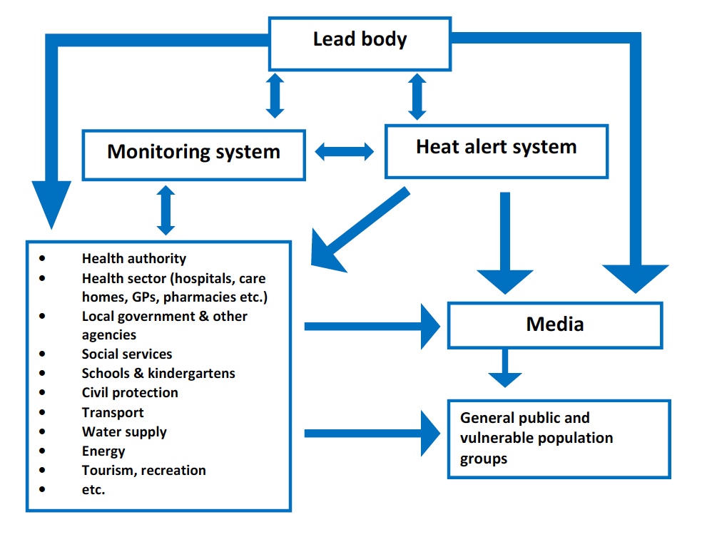

Figure 1. Potential flow of information between a lead body and other actors involved in heat action plans.

## Iterative management of decision-making structure

While it is important to set up a clear disaster management decision-making structure, it is crucial that these systems of management are reassessed iteratively over time, especially for when the structure is in place with a calendar year, if, for example with a heat wave action plan, the occurrence and management of disaster is only required at certain times of the year.41

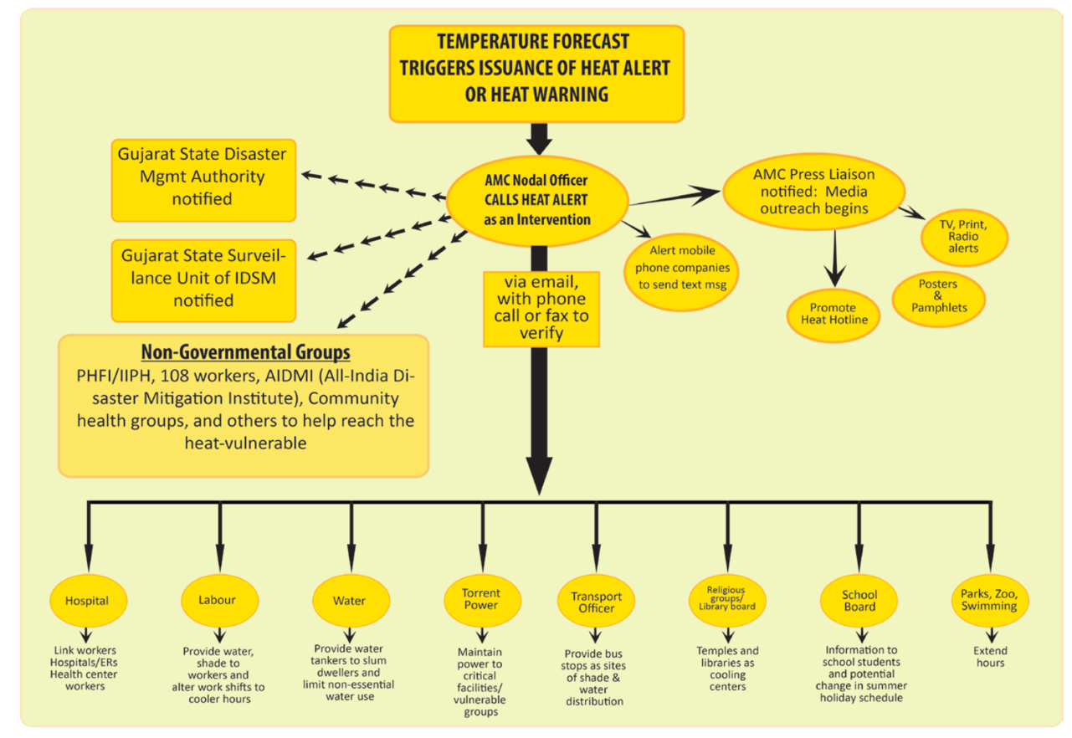

Figure 2. Communications plan for Ahmedabad Heat Action Plan

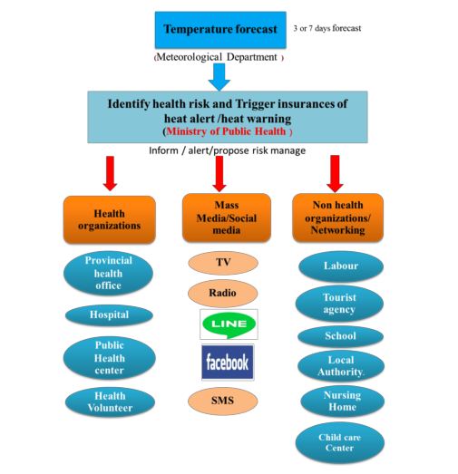

Figure 3. The proposed mechanism for heat health warning system in Thailand.

## Identity of decision makers

Public health protection from disasters, is a responsibility that is not restricted to the health sector. The health sector is positioned to address injuries and illnesses once they happen – but protection of public health is a civic responsibility of many. Be it through individual decisions made by individuals on behalf of their family, to professional roles and responsibilities inside or outside the formal health sector. Awareness of when and where a hazardous event may occur, in a timely manner can allow ‘decision-makers” to make the best call based on the information available to minimize health risks.. These “decision-makers” include, but is not exclusive to:

* National governments
* Local and state government, including social care and school authorities, responsible for vulnerable populations such as children and elderly.
* Employers and private sector
* Social and advocacy groups
* Community groups
* First responders
* Public utility managers (Water, Sanitation, Electricity, Roads, etc)
* Health system managers, ambulatory care services, private and public health care providers
* Individuals and families

## Timeline of key decisions and processes

Taking the example of an extreme temperature event, the WHO recommends an approach with five time frames, which cover long-term preparation as well as responses after the disaster42 :

* (Long –term) Longer-term development and planning
* (Pre-hazard season) Timely preparations before summer (pre-summer)
* (During heightened hazard season) Prevention during the summer
* (Event management) Specific responses to periods of heat/heat waves
* (Post event) Monitoring and evaluation

These timelines are depicted in Figure 4, addressing heat wave preparation:

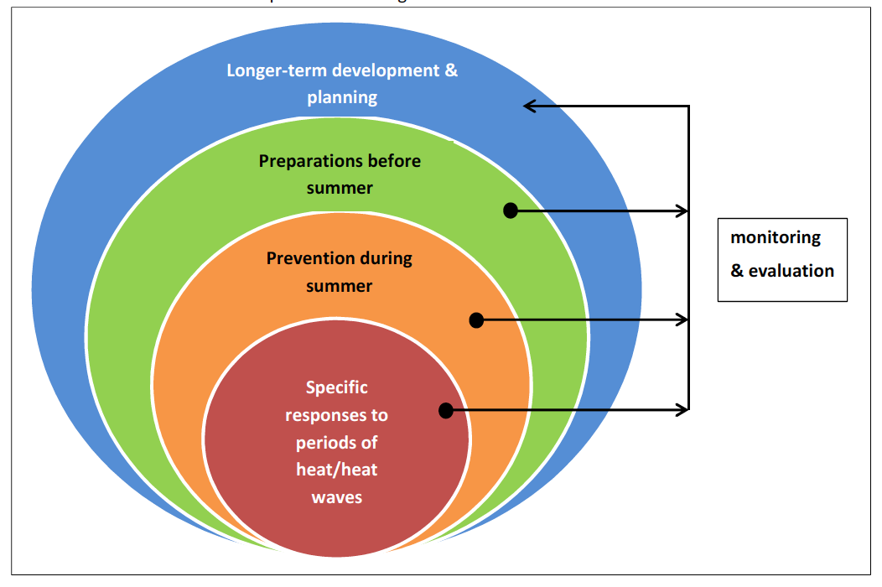

Figure 4. SWAP OUT Schematic representation of time frames set out by WHO for implementing the core elements of a heat action plan.39

# Annex 2: Key metrics to track health impacts of and vulnerability to disasters

The health impacts of the five focus hazards are measurable in different ways. Disaster-related metrics provide a key quantification of the effect of disasters on mortality, however morbidities and other impacts are often more far reaching and better measures of a hazard impact on public health. Several global monitoring processes have been created with relevant indicators that may be able to support Hi-Weather research (Table 3):3,43,44

Table 5. Indicators from monitoring processes relevant to disasters.

|  |  |  |
| --- | --- | --- |
| **Monitoring process** | **Disaster(s) relevant** | **Indicator of Impact** |
| Lancet Countdown | 5 (heat) | 1.2 Health effects of heatwaves |
| 1,2,3,4,5 | Climate-resilient health infrastructure |
| Sendai Framework for Disaster Risk Reduction | 1,2,3,4,5 | A-1: Number of deaths and missing due to hazardous events per 100,000 |
| 1,2,3,4,5 | A-2 Number of deaths due to hazardous events |
| 1,2,3,4,5 | A-3 Number of missing due to hazard events |
| 1,2,3,4,5 | B-1 Number of affected people per 100,000 |
| 1,2,3,4,5 | B-2 Number of injured or ill people due to hazardous events |
| 1,2,3,4,5 | B-3 Number of people who left their places of residence due to hazardous events |
| 1,2,3,4,5 | B-3a Number of evacuated people due to hazardous events |
| 1,2,3,4,5 | B-3b Number of relocated people due to hazardous events |
| 1,2,3,4,5 | B-4 Number of people whose houses were damaged due to hazardous events |
| 1,2,3,4,5 | B-5 Number of people whose houses were destroyed due to hazardous events |
| 1,2,3,4,5 | B-6 Number of people who received food relief due to hazardous events. |
| Sustainable Development Goals | 1,2,3,4,5 | 1.5.1 Number of deaths, missing persons and persons affected by disaster per 100,000 people |
| WHO Climate and Health Country Profiles | 5 (heat) | Heat-related mortality |
| 1 (flooding) | Exposure to flooding due to sea level rise |
| CRED |  |  |
| WHO Platform for Air Quality |  |  |

# Annex 3: Flood conditions that would trigger activation of an emergency plan

From Table 6. Flood conditions that would trigger activation of an emergency plan7

|  |  |  |
| --- | --- | --- |
| **Country** | **Definition** | **Category of definition** |
| Albania | Critical depth of groundwater | Scientific threshold |
| Armenia | No specific definition, case-by-case basis |  |
| Azerbaijan | Massive flooding in several districts | Scientific threshold |
| Bosnia and Herzegovina | Shortage of safe water and/or houses flooded with water; extensive flooding endangering population settlements, infrastructure, roads, railways, etc. | Population effects |
| Croatia | Disastrous flood | Population effects |
| Czech Republic | Third level of emergency plan | Population effects |
| Georgia | Disruption to normal lifestyle and working conditions, threats to life and health or harm to the population and natural environment that demands immediate action | Population effects |
| Hungary | An emergency situation due to flooding is declared when the water level reaches the critical threshold value defined for the given part of the river, and further increases are forecast. | Scientific threshold |
| Israel | The protocols for mass casualty events are immediately activated in any emergency in which there is a discrepancy between needs and the ordinary resources that are available. When there is a forecast of a potential emergency, such as a flood, the resources are reinforced and alerted in advance. | Temporal perspective |
| Kyrgyzstan | None given |  |
| Malta | None given |  |
| Netherlands | If a flood or the threat of a flood occurs on a national level because of a storm surge or high river water levels in one of our two main rivers (Maas, Rijn) | Scientific threshold |
| Poland | Flood that affects a significant population on health-related issues and/or destroys property to a degree that exceeds the local ability to respond | Population effects and temporal perspective |
| Republic of Moldova | When a flood causes considerable material and mortal damage, covering relatively large plots of land in river valleys; flooding of approximately 10– 15% of agricultural lands; significantly disturbing the household and economic activity of the population, leading to partial evacuation of people | Population effects and scientific threshold |
| Serbia | None given | Population effects |
| Slovenia | The National Protection and Rescue Plan in the event of floods shall be activated in the event of a catastrophically high water level | Scientific threshold |
| Spain | None given |  |
| Sweden | A flood with such consequences that it affects society’s critical functions requires a disaster management plan. This can be an infrastructure or a service that is important for the functioning of society (such as reservoirs, roads, railways, electrical networks, water pipes, sewer systems). | Population effects |
| Tajikistan | Any flood that causes any damage to community assets or loss of life | Temporal perspective and population effects |
| The former Yugoslav Republic of Macedonia | Increase in water level of rivers and lakes so that they overflow for over 24 h | Scientific threshold |
| Turkey | If the flood has affected the life of the population in that area and caused loss of life and property | Temporal perspective and population effects |
| United Kingdom (England and Wales) | An event that threatens to cause serious damage to human welfare. The National Resilience Capability Framework, led by the Cabinet Office, is the Government framework for determining and assessing a range of threats and hazards. | Temporal perspective and scientific threshold |